**LEBANESE AMERICAN UNIVERSITY**

**USAID – HIGHER EDUCATION SCHOLARSHIP PROGRAM**

**HES - Volunteering Program Verification Form**

This form is to be used to document volunteering hours. If a student volunteers for multiple organizations, a separate form must be used for each organization. **This form must be turned in by the 28th of each month, the latest.**

I certify that the scholar Lama Serhal completed a total of 1 hours of service at Life Sculptor.

The hours were completed hours as per the below:

Hours # 0 (date) _30/09 – 5/10_ (initials of supervisor) __A.K.___

Hours # 0 (date) _7/10 – 11/10_ (initials of supervisor) __A.K.___

Hours # 0 date) _14/10 – 18/10 (initials of supervisor) __A.K.___

Hours # 1 date) _21/10 -25/10 (initials of supervisor) __A.K.___

Brief description of the activities the scholar performed or participated in:

Research Topic: Biohacking and Wearable Health Tech   
IX. Biohacking for Health Optimization  
B. Discussion on biohacking for longevity, stress management, and disease prevention  
  
X. Ethical and Legal Considerations  
A. Overview of ethical considerations in biohacking and wearable health tech

Written feedback about the scholar’s performance:

Lama's research on biohacking and wearable health technology thoroughly examines health optimization strategies and addresses critical ethical and legal considerations. Her insights into longevity and stress management highlight the importance of responsible innovation in this rapidly evolving field.

Please rate the overall performance of the scholar at your organization:

|  |  |  |  |
| --- | --- | --- | --- |
|  | Mastery (5) | Proficient (3) | Emerging (1) |
| **Problem solver** | X |  |  |
| **Engaged & Committed** | X |  |  |
| **Open-minded & multicultural** | X |  |  |

Signature

& stamp

__________________________

_

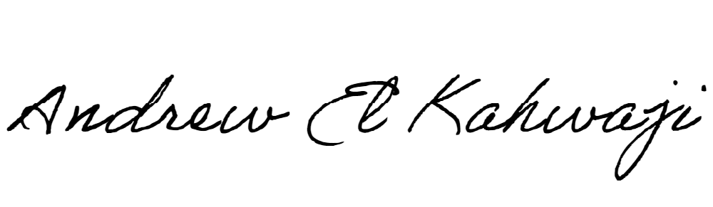

Printed Name _Andrew El Kahwaji_

Date __26/10/2024___

Email __andrew.lifesculptor.coo@gmail.com __

Phone __+961 71 914 378__

**LEBANESE AMERICAN UNIVERSITY**

**USAID – HIGHER EDUCATION SCHOLARSHIP PROGRAM**

